**Solar Power Inquiry Group Discussion - Science 10 – CD2 – SmartFlower**

In small groups, students should converse about the following questions.

1. What is solar power?
2. Which Canadian province has the highest potential to generate power with solar? Why?
3. Which of the following biomes is most likely to contain a large-scale solar power plant?
   1. Tropical rainforest
   2. Temperate deciduous forest
   3. Subtropical desert
   4. Deciduous forest
   5. Tundra
   6. Temperate Grassland
4. Rank the biomes listed in #3 in order of most likely to contain a large-scale solar power plant to least likely.

___________ > ___________ > ___________ > ____________ > ____________ > ___________

1. Explain your answer to #3.
2. What is the best way to set up a solar panel in Saskatchewan?
   1. Laying flat on the ground
   2. Tilted and facing the South
   3. Tilted and facing the East
   4. Tilted and facing the North
   5. Tilted and facing the West
3. Explain your answer to #6
4. Does the sun rise at the same time every morning and set at the same time every night throughout the year in Saskatoon? Explain your answer.
5. Is there anywhere in the world where the sun does set at the same time every morning and rise at the same time every night? Explain your answer.
6. Do all locations in the world experience four seasons (spring, summer, fall, winter)? Explain why, or why not.
7. Does anywhere in the world experience just one season or two seasons? Explain why or why not. If yes, what are they called?
8. Are there places in the world where objects don’t cast shadows at certain times of the year? If so, how is this possible?
9. Are there places in the world where the sun doesn’t rise for months? If so, how is this possible?
10. Are there places in the world where the sun doesn’t set for months? If so, how is this possible?
11. 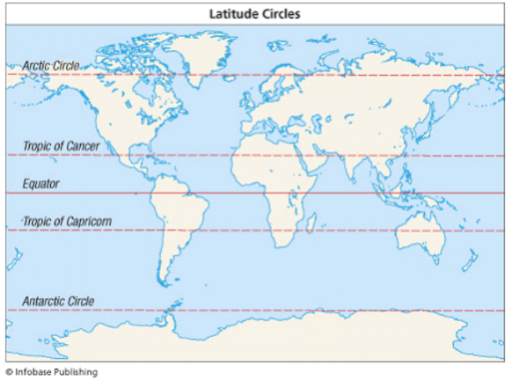The following diagram is a map of the world that includes the five very important lines of latitude.

Why do most maps contain these lines?

What do they relate to exactly?