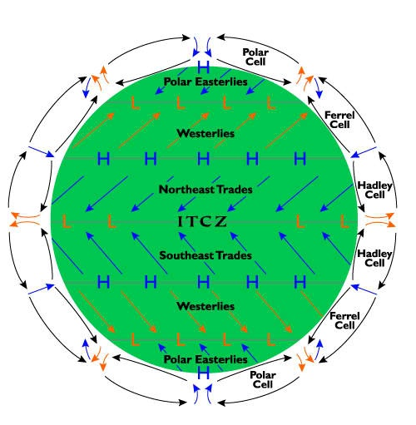
CD2 – Global Convection Currents Worksheet
- On the following diagram label six places where clouds are most likely to form and six places where clouds are unlikely to form/dissipate. (label on the outside of the diagram above the arrows)

- What is the ITCZ labelled on the diagram above and how is it easily viewed from space?

- Complete the following model. This is called The ________________ Model. 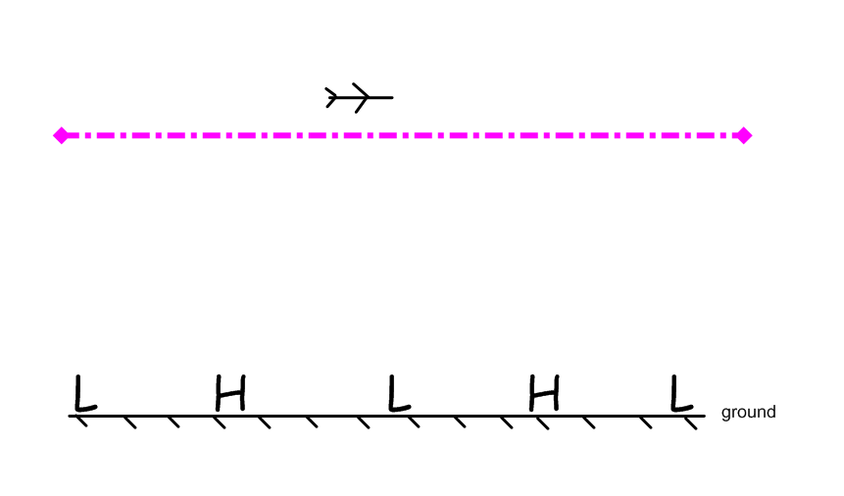
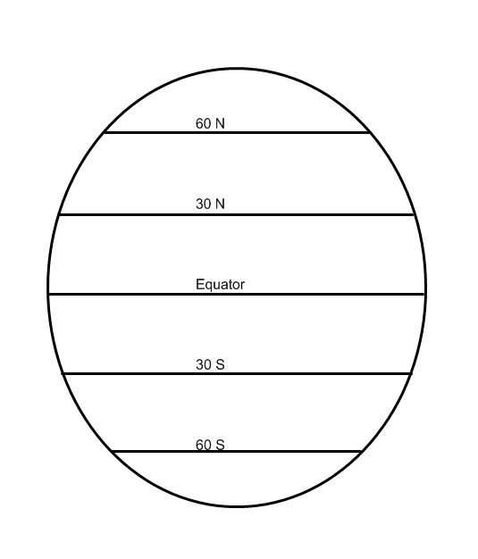
- For each of the following lines of latitude label each line to indicate whether the general condition is moist (cloud, rain, forest) or dry (clear, dry, desert).

- For the following diagram state whether there is a center of convergence or a center of divergence along each line. Then state if there is low or high pressure common along the line. Finally, state the biome that is most common along the line.

At 60 S there is little to no land mass. Follow the pattern and fill in what type of center, pressure, and biome would be expected if land was present there.

Latitude | C. of Convergence or C. of Divergence | Low or High Pressure | Common biome | Ideal Environment for Solar Power Production (yes or no)
60 N
30 N
Equator
30 S
60 S
