CD2 – Coriolis Effect and Global Ocean Currents
- Draw the Gulf Stream ocean current (Just one single arrow)
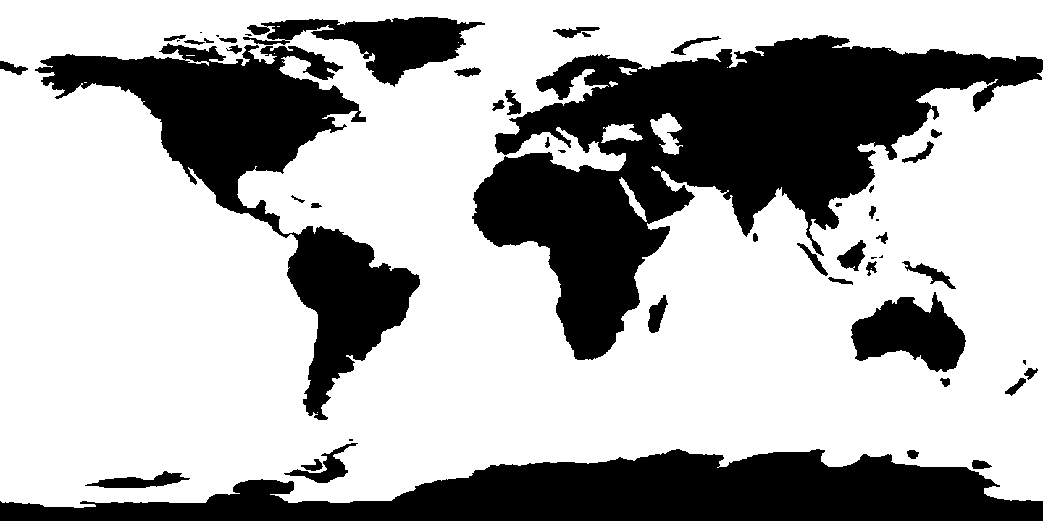
Is the gulf stream a warm or cold current?

Why is it warm or cold?

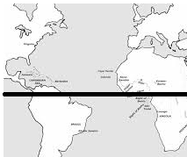
- Draw the ocean currents on the following map of the Atlantic Ocean. Use red pen to show the warm currents and blue pen to show cold currents. If you don’t have a red/blue pen then write the words warm and cold with the current. You should be drawing four curved arrows north of the equator and four curved arrows south of the equator.

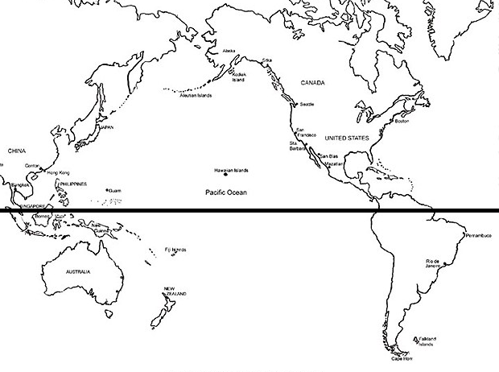
- Draw the ocean currents on the following map of the Pacific Ocean. Use red pen to show the warm currents and blue pen to show cold currents. If you don’t have a red/blue pen then write the words warm and cold with the current. You should be drawing four curved arrows north of the equator and four curved arrows south of the equator.

- Why are warm ocean currents warm?
- What are cold ocean currents cold?
- Most of Southeast Asia is covered in rich forests, while most of western Mexico and the southwest USA are covered in deserts. These locations are both in the dry 30ºN band that we talked about yesterday.
  - What kind of ocean current flows toward SE Asia? Warm / Cold
  - What kind of ocean current flows toward SW USA and western Mexico? Warm / Cold
  - True / False : ocean currents have a profound impact on the biomes and climate regions of the Earth
- What is the better location for large scale solar panel installations, along the coast of a warm current or along the coast of a cold current? Explain your answer.

- Given this information suggest which is a better location for large scale solar panel installations, Western Australia, or Eastern Australia. Explain your choice.

- Find and describe another example on your biomes map where there seems to be an exception to the normal dry/wet/dry/wet/dry pattern we drew yesterday on our biomes map. (Hint: look at the biomes map and your ocean currents map to see if warm currents make changes to the normal pattern of 30ºN / 30ºS dry desert, 60ºN taiga.) Explain how this is likely due to the warm ocean current.

- All ocean currents are connected in one system called the Ocean ______________ _______. In this model the ___________ water flows near the surface and when it cools it ________ rapidly and flows underneath the warm currents in the __________ direction.
- Due to the Coriolis effect, objects in the Northern Hemisphere (north of the equator) deflect to the ___________. Due to the Coriolis effect, objects in the Southern Hemisphere (south of the equator) deflect to the __________.
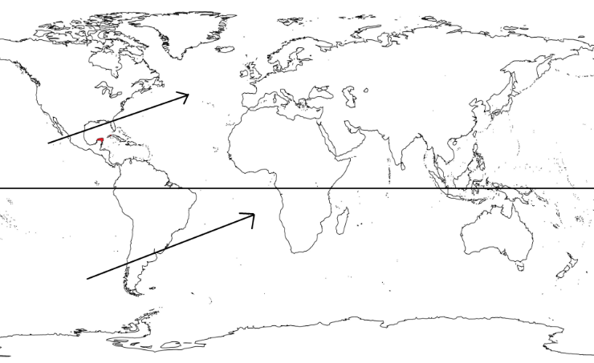
- Show how the following two intended paths would be affected by the Coriolis effect.

