**Computer Basics: Email**

In this course we will introduce you to Gmail. We will then look at your Inbox layout and how to keep it organized. We will practice composing, sending and receiving email, as well as sending and receiving email with attachments. We will also discuss how to recognize scam and phishing emails.

**Learning Objectives**

Importance of strong passwords

Understand inbox layout

Compose an email

Sending an email with an attachment

Reply to an email (reply, reply all, forward)

Open and download an attachment

Safety, security and etiquette when using email

**Preparation**

**\*\*Before class:**

* **Send an email to the** [**digit.siec@gmail.com**](mailto:digit.siec@gmail.com) **from** [**digitalliteracy@saskatooniec.ca**](mailto:digitalliteracy@saskatooniec.ca)**. The email will request a reply with an attachment.**
* **Send an email to the email accounts that are being used for the class from the** [**digit.siec@gmail.com**](mailto:digit.siec@gmail.com) **account.** This email will also request a reply with an attachment**.**
* When you arrive on site, introduce yourself and get any relevant information, including wifi password
* Set up all learner computers and make sure they are connected to the wifi (hotspot if necessary). Put to sleep.
* Place an email address (on laminated cards) next to the paired computer. (computer number is in top right corner of laminated cards)
* Set up the projector and connect to your computer. Tape cords down to the floor with yellow duct tape if needed.
* Set up the portable screen if needed.
* Open Slide Show (Computer Basics: Email) (make sure all the slides you will use are “unmuted”).
* Open [digit.siec@gmail.com](mailto:digit.siec@gmail.com) account.
* (For some, this requires you to be signed into 2 Gmail accounts at once. Your personal SIEC account, if you have one, will not allow you to access Gmail, but the [digit.siec@gmail.com](mailto:digit.siec@gmail.com) account will.)
* Prepare slides and show the first one on the wall.
* Resize your mouse pointer to 4 and choose a colour (ie bright green) Settings->Accessibility->Mouse Pointer and Touch->Size->4

**Materials**

* Laptops
* Projector and portable screen
* Presentation Clicker
* Portable whiteboard/marker
* Set of pens
* Extension/HDMI/VGA cords
* Wifi hotspot
* Teaching resources
  + Teaching Guide Binder
  + Visual presentation
  + Laminated email address cards
  + Handouts for learners
* Surveys (if necessary for any newcomers to the class series)- use the link on desktop or paper copies
* Duct tape (yellow)
* Name tags/markers

Have DigIT slide showing as learners come in and get seated.



(Switch to Computer Basics:Email slide)

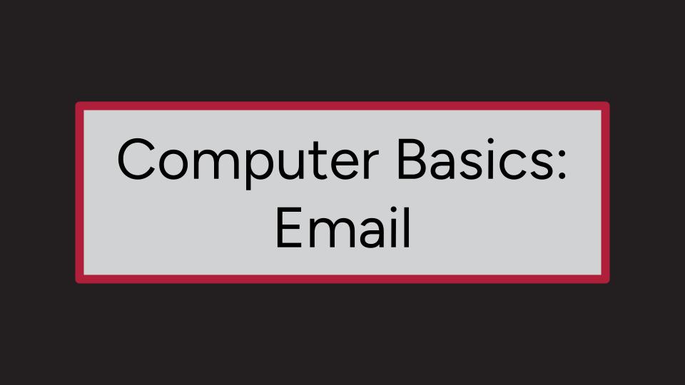

Introduction

Introduce yourself and the DigIT program. Welcome everyone to class.

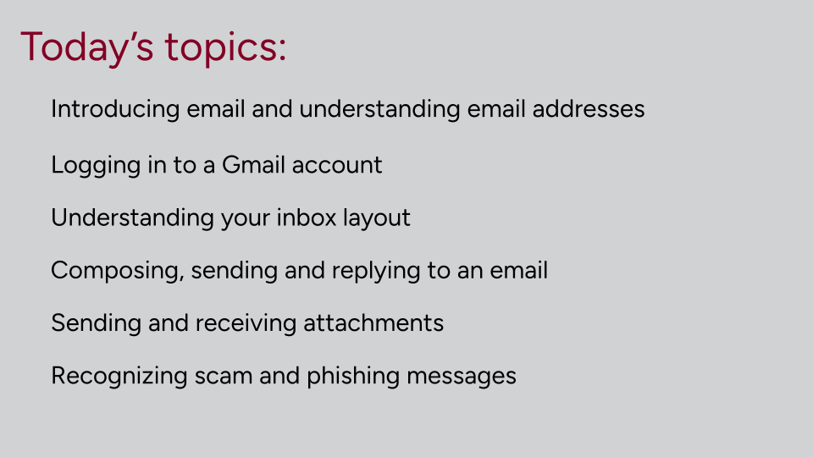slide is animated

Email is a way to send and receive messages across the internet. It works the same way as regular mail, except that it is sent electronically through the internet and it arrives in your email mailbox, or inbox almost instantly. Email is a great tool for communicating and staying connected.

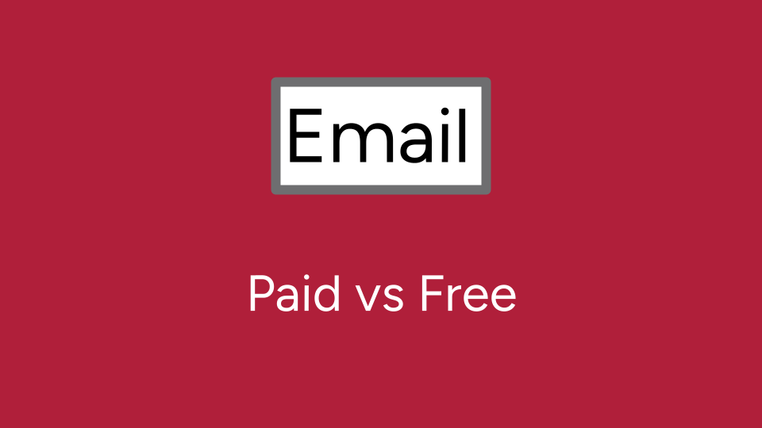

There are two kinds of email services - paid and free.

* Paid is when it is through your internet or phone provider, such as Sasktel or Shaw, and they give you an email address as part of the service.
* Free is when you sign up for an account such as with Google or Outlook and it doesn’t cost you anything.
* It's best not to use an email account tied to your work, school or internet provider as your main account, since those things may change and your account would not be active anymore.



We will be working with Gmail today. If you have a different email service at home you should be able to follow along since they all have the same features, just a different look.

Does anyone already have a Gmail or Google account?

A Gmail account will give you access to many other great google tools and applications, as well.

Understanding email addresses

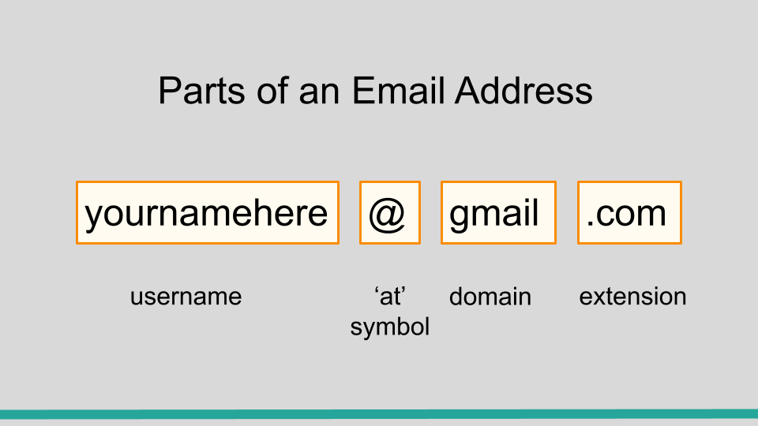

Email addresses are always written in a standard format that includes a username, the @ symbol, the email provider’s domain, and the extension.

* The username is the name you use to identify yourself, such as jane.smith.
* The email provider is the website that hosts your email account, such as Gmail or sasktel.
* The extension is the last part and comes after the dot, such as .com or .ca.

All of these must be entered correctly or the email will not get where it needs to go.

Signing In



* Open up Chrome on your laptop
* Go to [gmail.com](http://www.gmail.com) or use grid
* Does everyone know how to get the @ symbol on their keyboard?



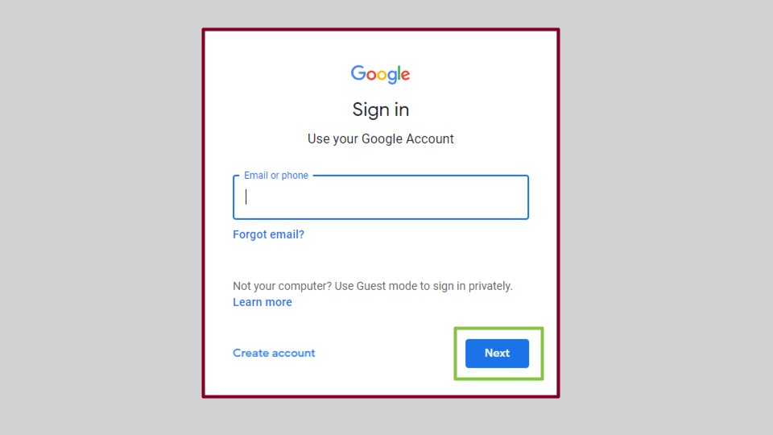

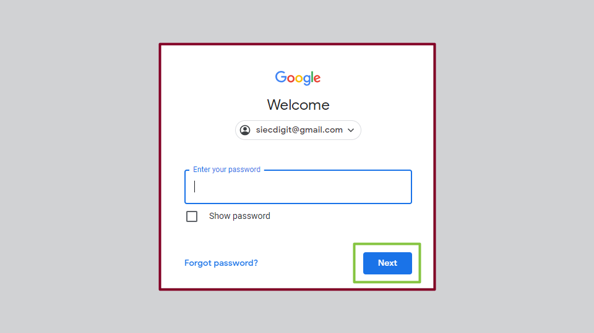

Everyone should now be signed in to their email account and it should look something like this:

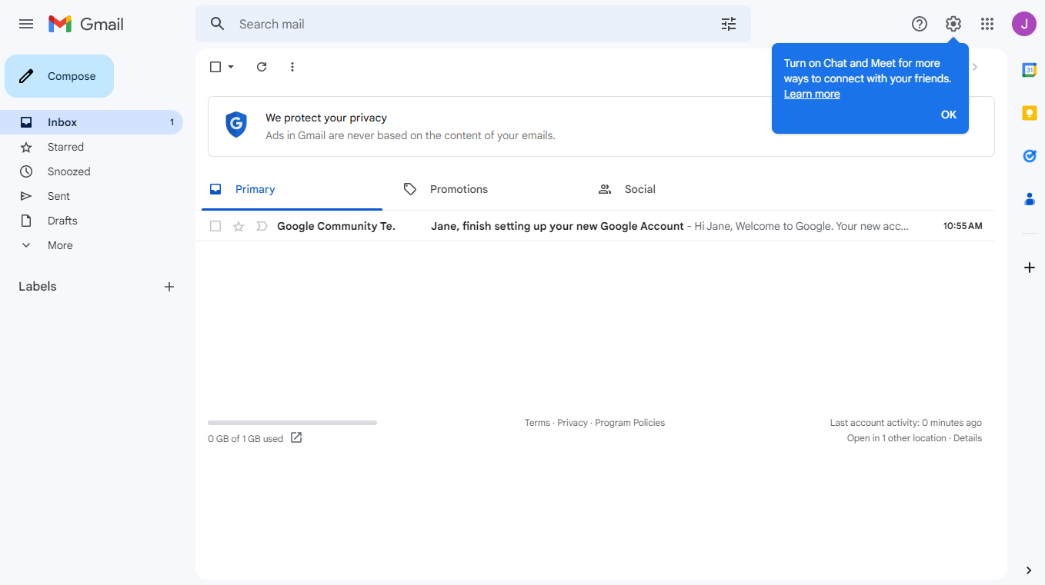

**Screen Sharing**

Maximize the [digit.siec@gmail.com](mailto:digit.siec@gmail.com) account

Inbox layout

The inbox is where you will see and manage the emails you receive. They are listed with the name of the sender, the subject of the message and the date it was received. All email providers have a similar layout. Most of them can be customized to suit your needs. We’ll be looking at the basics today.

On the left side of the screen you will find all your folders. This will help you keep your inbox organized. Let’s talk about a few of them now.

* Your inbox contains all the emails that have been sent to you
* Your sent folder has copies of all the email messages that you wrote and successfully sent.
* Drafts is where you can find an email that you wrote but haven’t sent yet.
* Trash is where messages go when you ‘delete’ them. There are a couple of ways to delete mail. Demonstrate: using check box and trash can symbol as well as right click menu where you can choose Delete. This sends them to the trash folder. They stay there until you choose to empty that folder.
* Your Spam folder is where junk mail goes. Google has a filter and will sort it for you, but sometimes important messages will end up there. It is a good idea to check it regularly.

Above your folders you will see a compose or new message button.

Reply With an Attachment

Have learners put their laptops to sleep and watch the screen at the front.

Now everyone should have received an email from digit.siec@saskatooniec.ca.

You can tell if an email has not been read because it is bold.

Click on the email from DigIT. This opens up a new window where you can read your email. Or it might open it to the right side of the inbox.

* Scroll to the bottom and you will see some options.
  + **Reply** - does what it says. You can reply to the person who sent it to you
  + **Forward** - you can send this same email on to someone else. When you do this, it is a good idea to include a brief explanation about why you are sending it.
  + **Reply All** - if multiple recipients are included in the message you can choose to just reply to the sender or everyone who was included in the message. You won’t see this option if there is only one other person in the exchange.
  + Talk about the symbols and how they might appear on a message in your inbox that you have replied to or forwarded
* If you usually use an email service that isn’t Gmail, you might find the reply and forward buttons somewhere else in the window but they will be there. All email providers have these options. Check in the toolbar at the top of the message or of your whole email window.

This email requests that we send an attachment in our reply. An attachment is a file you can send with your email. It can be a resume, picture or any other document that you have on your computer. When we reply to this email we are going to look for the little picture of a paperclip. It is sometimes in the bottom of the window but you might also find it in the top. I like to add my attachment first, so I don’t forget, but you can do it after you have filled everything else out if you prefer.

* If we hover over it see how it says ‘attach files’?
* When we click it we get a window popping up with access to all the files on our computer. You have to know where you have stored the file you want to send.
* Now let's double click on ‘desktop’.
* Find the folder that says **Email** and double click that.
* Double click on one of the photos to open and attach to your message.
* You will now see the name of the file at the bottom of your message window.

Notice that the recipient field has the address of the email you are replying to.

Make sure to include a subject (you can just put in ‘**photo**’).

Now in the body of your email, say that you have attached a photo for them. This is an important step because your recipient might not be expecting a photo from you and may not notice it.

**I have sent you a photo of ….**

When you are happy with the message and the attachment you can click send.

Have learners open their laptops. Walk through the process together this time.

* Give everyone a few minutes to compose their reply email and find an attachment and send.
* To go back to your inbox click the back arrow in the toolbar at the top.
  + You can also click on the word inbox in the folder section or click on Gmail in the top left corner.

Compose an Email With Attachment

Have learners put laptops to sleep and watch the facilitator.

Compose or ‘new’ button will allow you to write your own message to someone.

* Click on the ‘compose’ or ‘+’ ‘new message’ button.
* A compose pane comes up to create your message.
* Click in the ‘to’ field and type the recipient (person you want to send it to). You can send to more than one person at a time if you want. You can add multiple recipients in the ‘to’ field but this time we will just send to one. Type in an address (facilitator uses digitalliteracy@saskatooniec.ca)**,** making sure to check for accuracy.
* Click in the subject field. You should enter a title in the subject line - your recipient will like to know what the message is about.
  + Type **practice**
* Click in the space below the subject line and type in a simple message. This is called the body of your email. Remember to start with a greeting such as hello and end with a signature, just as you would a regular letter.

**Hello**

**This email is for practice**

**Jane**

* Read it through and make sure everything is correct. (recipient address, spelling, etc.)
* Click Send. This button is usually at the bottom, but may be located elsewhere on your screen.

Have learners open their laptops and switch their email card with the person sitting next to them.

Walk through the process together this time.

* Give everyone a few minutes to compose a message, attach a picture and send their partner the email.

Receiving an attachment

Click to open up the email you just received from your partner. If you scroll to the bottom of the message you will see the attachment. Click on the icon to open it up. Now you can see the full photo.

Now we will download our attachment to the downloads folder. You will find the download button in the top right of your screen. The downward pointing arrow with a tray underneath is the universal symbol for download. Click once on it. If you look on the taskbar you will see a file folder icon. Click once on that. Look for the folder called Downloads and double click on that. Find the attachment on the list that pops up and click on that. You can move this file to a different location to make it easier to find when you need it next. For now though, let's delete it. Click on the 3 dot menu and choose “see more”. Look for the garbage can and click on it. Choose delete one more time.

Forwarding an Email

Now let’s forward that same message.

* Click on it to open it again.
* Now click forward and send it to **digit.siec**[**@gmail.com**](mailto:jane.olivia.smith.23@gmail.com)
* As you start typing, the address might come up automatically. If it does, then go ahead and click it.
* Once the address is in then click in the space below and type a quick message like ‘fyi’ or **‘for your information’.**
* Click send.

Safety and security

We have practiced sending and receiving emails from our partners. But sometimes you will get emails from people you don’t know or even names you recognize but the message seems weird. An unexpected or unusual tone from someone you know can be a red flag that something is amiss. If you aren’t sure about it, then contact the person who sent it to you (make a fresh start, don’t respond directly to the fishy email) to make sure it actually came from them. Only open attachments from people you trust and only if you know why they are sending it to you. Email attachments are a common way for cyber criminals to gain access to your computer.

Also be careful about emails asking you to provide personal information. These are called phishing emails. They will try to trick you by posing as a trusted institution like a bank, charity or employer. These messages often have an urgent tone so you will be tempted to act quickly without thinking it through. If you give them your personal information they can use it to impersonate you and commit acts of fraud.

We offer another class on internet safety and security where we talk more about this and how to recognize it, but for today, we just want you to be aware that you should trust your gut instinct whether an email message sounds suspicious and proceed with caution.

We also have a handout for you on some things to look for.

Before we finish for today, let's delete the emails you have received. Select the emails by clicking the small box beside each email you want to delete. You can do many at once. When all the boxes are checked, look at the toolbar that appeared above. Choose the trash can. This should delete the selected emails. You can also move them back into your inbox if you change your mind. Messages in Gmail trash are deleted after 30 days but different email providers might have different ‘rules’.

Sign out

Let’s sign-out. In the top right of your window you will see a coloured circle with your initial in it.

* Click on it then click ‘sign-out’

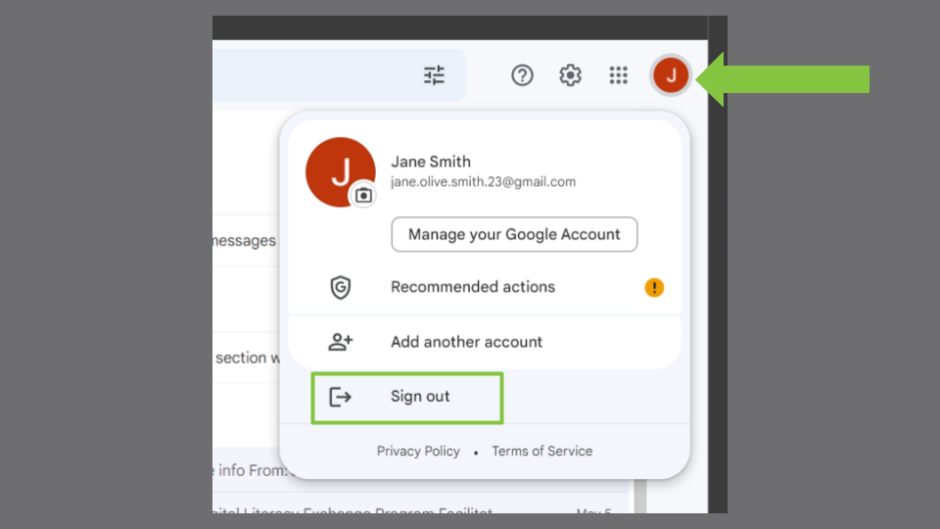

* You have signed-out of your email account, which is a good thing to do when you are finished, especially if you are on a computer or device that other people use. Leaving your email open is like leaving your house unlocked - anyone can come in and look at or take your stuff.

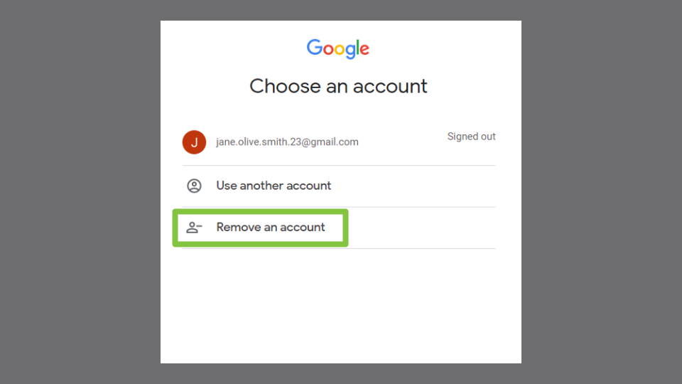

* We will now go one step further, which you should remember to do if you are using a public computer like in a library or something but isn’t as important if you are the only one using your device. We will remove the account. This only removes your account from the list so your computer won’t remember it the next time you go to log in.
* click ‘remove an account’

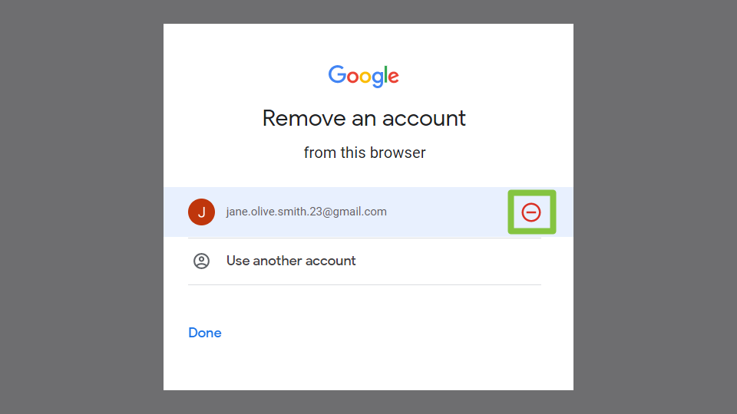

* Click the red symbol beside your account

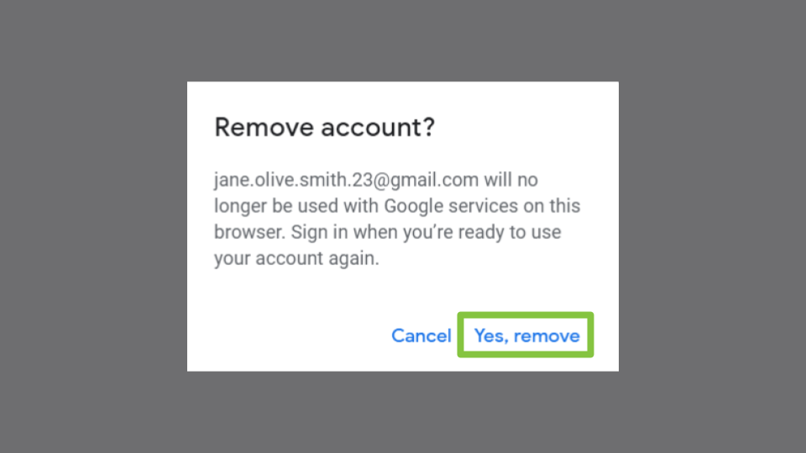

* + Click ‘yes, remove’
* Now close out of the browser window (X in top right corner)

Closing

We moved quickly through some of the information. In the time we have left, let's take a quick look at the handout (briefly highlight what is in it.)

Are there any questions about what we have covered?

(take questions)

(If this has been a stand alone class, have the class do the survey before they leave.)

We received funding from the Government of Canada to build this program and we are collecting statistics on who this funding is reaching.

* We have a link for you on the desktop or a paper copy

If anyone wants help setting up their own Gmail account we can help you with that now.

If you are interested in learning more about your email and how to personalize the settings to make it work for you, let us know. We are looking at future classes.

***record any good anecdotes